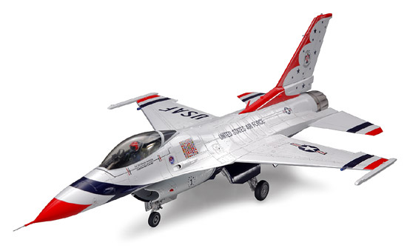  F-16 Thunderbird | F-16 Thunderbird | F-16 Thunderbird | F-16 Thunderbird
F-16 Thunderbird | F-16 Thunderbird | F-16 Thunderbird | F-16 Thunderbird
F-16 Thunderbird | F-16 Thunderbird | F-16 Thunderbird | F-16 Thunderbird
F-16 Thunderbird  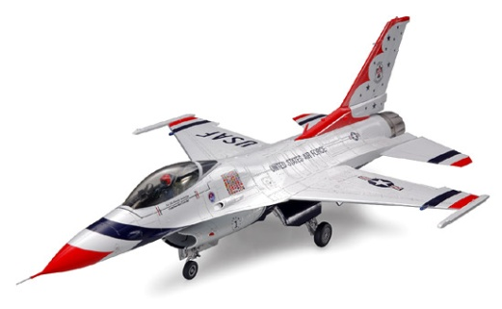 | 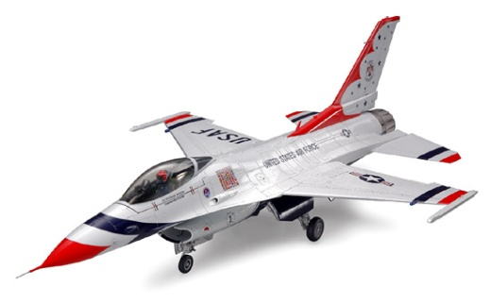  F-16 Thunderbird | F-16 Thunderbird | F-16 Thunderbird

